Programming External EEPROM [Axiom CME11E9-EVBU]

[Must use the latest version of AXIDE SOFTWARE. Note this software will NOT RUN CORRECTLY on a machine running anything above WIN98!]

When finished with program development you can program your application into EEPROM so it executes automatically when you apply power to the board. The following procedure does this:

1. Make a backup copy of the .ASM source code.

2. Edit the source code so that the code goes into EEPROM and the variable space goes into ram. This can be done by adding two ORG statements, one before the variables and one before the program (no JMP MAIN required)

RAM $1040-$7FFF (U5)
EEPROM $8000-$b57F (U6 if installed)
EEPROM $B800-$CFFF (U7)

Also add the following:

LDS $7FFF *puts stack at top of ram

[for ICC11 users, you do not have to do the above, instead modify the PROJECT | OPTIONS | Target tab parameters for PROGRAM MEMORY, DATA MEMORY and STACK POINTER (hex format is 0x8000, for example)]

If A/D in use also add

LDAA #$93 *turn on A/D
STAA OPTION

[for ICC11 users OPTION=0x93;]

3. Re-Assemble your .ASM.

4. Start AxIDE (as shown in Fig 1) and press the Configure button and follow the onscreen instructions. Uncheck the ROMON bit.

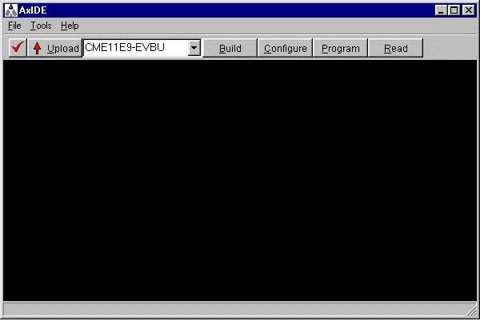
Figure 1 - AXIDE Screen

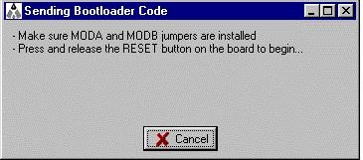
Figure 2 - Configuration Instruction Screen

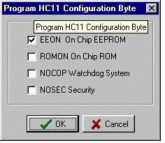
Figure 3 - Configuration bit selection screen

5. Select Program and make sure External EEPROM is selected.

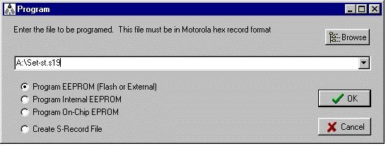
Figure 4 - Program Selection

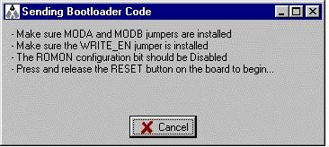
Figure 5 - On screen instructions

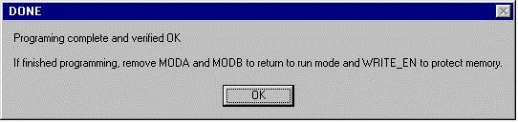
Figure 6 - Done message

6. At the file prompt enter your newly assembled *.S19 file.

7. Click OK then follow the onscreen instructions, installing the programming jumpers then power off/on or press the RESET switch.

8. Now create a second .ASM file that will set the reset vector to point to your code. This is done with the following:

org $FFFE

fdb $8000 *see note

note: this number should be the same as the ORG line for the PROGRAM (see step #2)

9. Select Program and make sure External EEPROM is selected.

10. At the file prompt enter your newly assembled *.S19 file.

11. Click OK then follow the onscreen instructions, installing the programming jumpers then power off/on or press the RESET switch.

12. When finished programming, remove the jumpers as instructed by the program.

13. Return to the AxIDE terminal window and cycle power or press RESET on the board. Your new program should start automatically.

To return to the buffalo monitor program, select Configure again and this time enable ROMON. The buffalo monitor on chip will execute the next time the board is powered on.

taken from CME11E9-EVBU documentation and modified by Dan Kohn

