CET 302 Journal

Reset / Clock Circuit

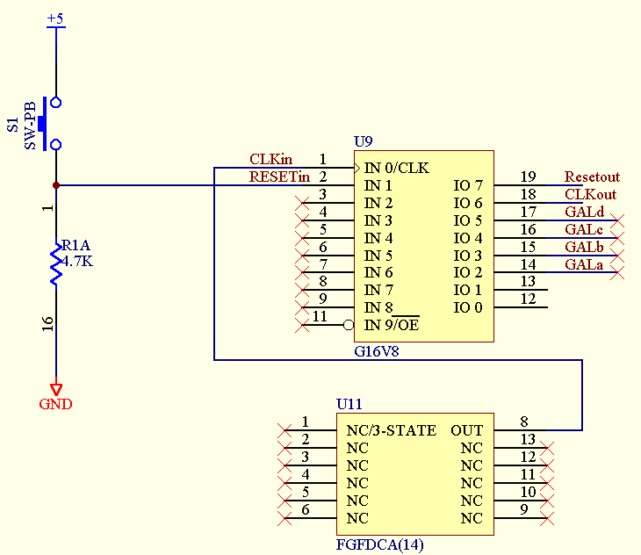

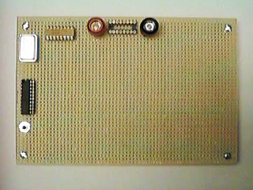

- Programming the PLD
  - Since reset switch is active high, the wincupl code had to be modified to allow an active high reset (see 8088clk-b.pld). Original code was left in protel file (8088 Project.ddb) in case students have an active low reset. In this case use the original code (8088clk.pld)
  - For the ALL-07 programmer use the following settings
    - DEVICE – PLD
    - 09. LATTICE
    - 008. GAL16VC

- Testing
  - Test Clock Input
    - Hook CH 1 of scope to CLKin (1) and verify the clock input signal (8MHz at 5v)

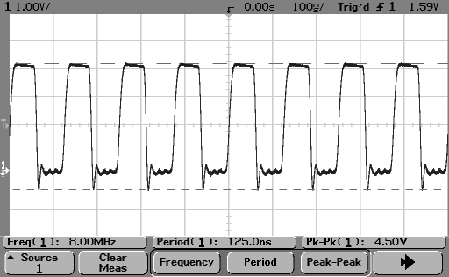

  - Test Reset Condition
    - Hook CH 1 of scope to RESTout(19) and CH2 to CLKout(19)
    - Set scope up for normal mode (mode couple – Normal), to trigger off of falling edge of CH2, and for single trigger.
    - Hit reset on 8088 board. Scope should stop (reset/stop button turns red)

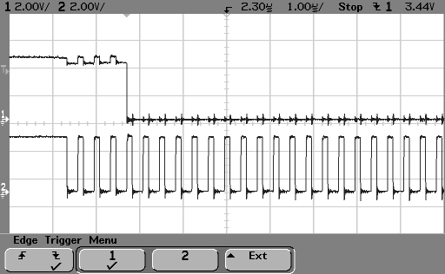

  - Test under normal run condition
    - Leave scope leads were they were
    - Set mode coupling to AUTO
    - Set up quick measure to CH 2 and measure freq, period and duty cycle

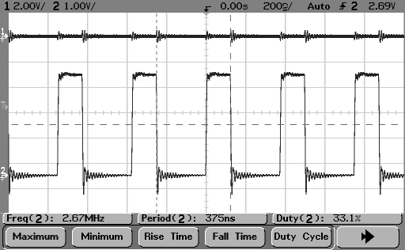

PROCESSOR

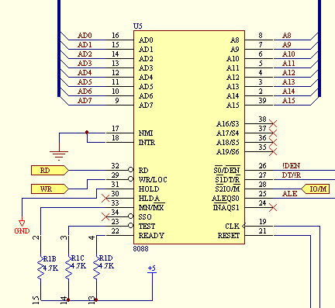

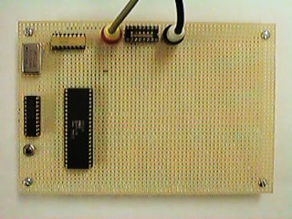

- Testing
  - To test the processor, a reset is given to the processor. After the reset has ended (indicated by a falling edge of RESET), the processor should fetch location FFFF0h from memory (Reset vector). The digital analyzer is set up to look at the MSB and LSB of each hex digit (ie A0 and A3 for the right most value and so on). As shown below, the bits coincide with the bits for the FFFF0H value on the first ALE high. This proves the processor is working and set up in the proper mode (and the control lines are set properly for normal processor operation)

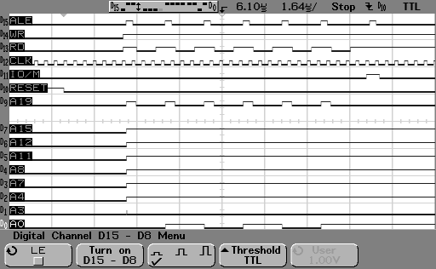

ADDRESS LATCH

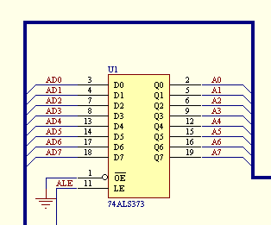

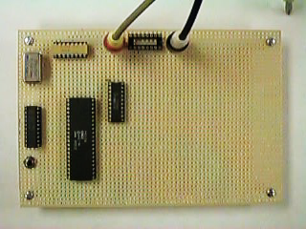

- Testing:
  - To test this part of the 8088 processor, the digital analyzer is connected to both the input and output sides of the 74373 IC and a reset is performed. The trigger is set up to trigger on the rising edge of the ALE signal. Since ALE must be an input, only AD0..AD7 and A0..A6 are shown.

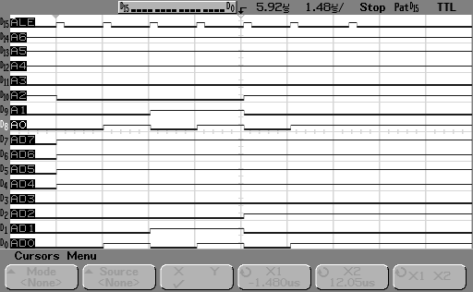

Again, FFFF0h should be on the address lines at the first ALE after a reset. This is shown by AD0..AD7 being F0H, A0..A3 show the 0, but since the address latch shows A4..A6 already being high, it is hard to see the first 3 bits of the “F”.

PROM Testing (Data Buffer / 74138)

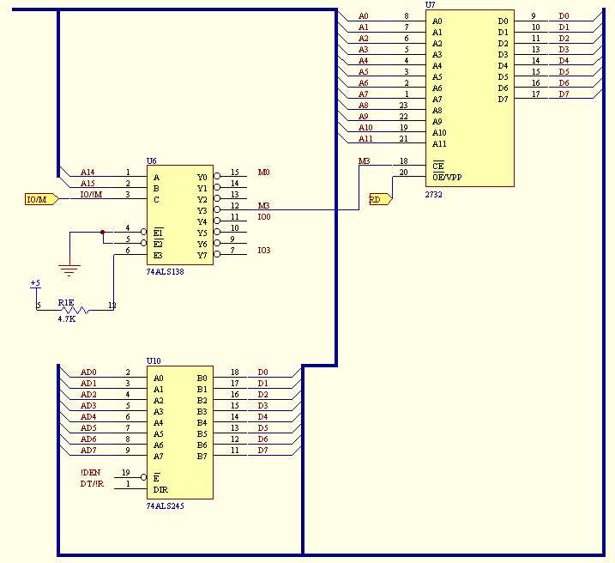

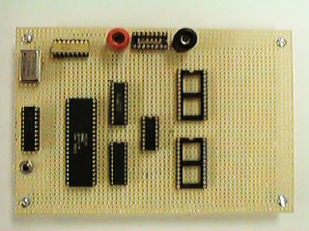

- Testing
  - Since memory is required to test the Data Buffer (74245), it was decided to test the 74245, 74138 and 2732 all in one shot. The additional circuitry that was wire wrapped is shown above.
  - Before testing commenced, the Eprom was erased using a UV prom eraser. The prom was left under the UV light for 15 minutes.
  - Before creating the asm code, an understanding of the memory map of the 8088 processor board is required. This board uses a number of “Tricks” to meet the criteria of the 8088 processor.

These criteria include: Prom at upper most memory (so that prom is addressed at FFFF0H for reset instruction) and RAM at lowest memory for interrupt table.

These tricks also allow for minimal address decoding to minimize the amount of wire wrapping required.

The memory map for the processor is as follows:

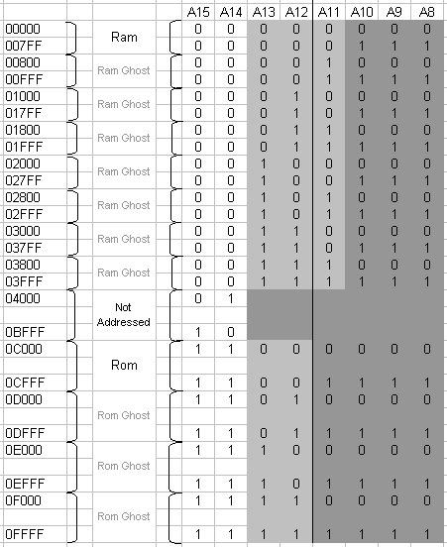

*Memory Map Repeats 16 times for most significant Hex Digit (0..F)

  - A program was written in A86 that would test the processor, memory and I/O functions. This program also places a JMP instruction at FFFF0h to point to the main program at the location 200H (a ghost location of the same prom). The Program’s list file (as generated by A86) is shown below:
1 org 0200H
2 0200 B4 00 mov ah,0h
3 0202 FE C4 Fred: inc ah
4 0204 88 26 0C 03 mov [030CH],ah
5 0208 8A 26 0C 03 mov ah,[030CH]
6 020C BA FF 3F mov dx,03FFFH
7 020F EC in al,dx
8 0210 BA FF FF mov dx,0FFFFH
9 0213 EE out dx,al
10 0214 EB EC jmp Fred
11
12 org 0ff0H
13 0FF0 EA 00 C2 00 00 JMP 0000H:0C200H

  - To compile the code, use the following command line
A86 %1.ASM %1.BIN %1.LST
Where %1 is the name of the asm file. The file to use in the ALL-07 programmer is the “BIN” file.
  - The prom was then placed in the programmer and the programmer was set up as follows:
    - Device – Eprom
    - Mfr – 01. AMD/MMI
    - Device – 002. 2732
  - When “Load[ing] Bin or Hex File” select <B>in with load address 0000
  - Once the Prom is programmed it is placed in the 8088 board, the digital analyzer is connected to appropriate pins and the analyzer is triggered off the falling edge of a reset. A reset is given and here is a small sample of the results on the scope:

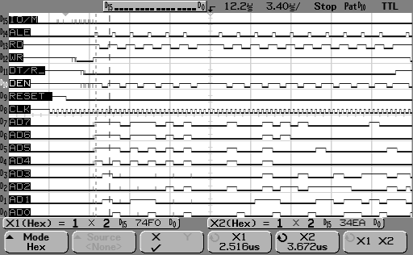

This is then analyzed to prove that the processor is retrieving the code written in the PROM. In the above example, the first cursor line (X1) is placed on the first ALE high and the cursor shows that the lower byte of data (AD0..AD7) contains an F0H (the lower byte of the first address called after a reset). The second cursor (X2) shows the first data retrieved from the PROM, in this case AD0..AD7 shows an EA which is the first op code of the program above. This proves that the processor was able to retrieve data from the prom, and also proves that the Address latch (74373), data buffer (74245) and the decoder (74138) are all connected properly.
  - A similar scope output was saved in a .csv file (but at a time scale of 10us per div). This was then analyzed using excel to show more of the program code and how it appears on the bus. (See ROM-PROGRAM2.XLS) for full analysis.

