eRTOS Programming Notes

Note before starting 2
Installation 2
Compiling the WEBSERV demo program 2

Note before starting
It would be beneficial to review the notes found in “Flashlite 386ex” especially those section on how to install Borland C and the use of the WATTCP library (since eRtos is written by the same programmer and many of the libraries for eRTOS are WATTCP libraries).

Installation
To install the eRTOS Development library into the Borland C unzip all files into the root of the Borland IDE (default is c:\BC45).

To start a project and setup the compiler, refer to http://www.jkmicro.com/documentation/pdf/start_ertos.pdf

Compiling the WEBSERV demo program
Follow the instructions above. Create a project (Project | New) and name it “webserv” and place it in the “..\projects\webserv” directory.

Add the following nodes:

Webpart.c
Webserve.c
\bc45\lib\ertostcp.lib
\bc45\lib\rtos.lib

Make sure that all files are off the root of the project. If they are you Project window should look as follows:

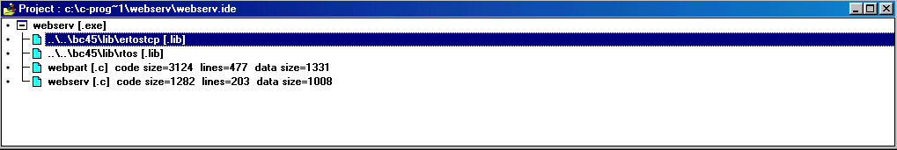

If they are not off the root of the project, a number of errors will occur during the build process.

[note: for some reason when compiled, the program is some 2.5 times larger than the original. Still need to investigate why?]

